CURRICULUM VITAE
 | Name (Block letters) | : | SOUMITRA DAS
 | Date of Birth | : | 15/01/1983
 | Nationality | : | Indian
 | Gender | : | Male
II. | Department | : | Philosophy
III. | Area of Interest | : | Applied Ethics: Euthanasia, Suicide
IV. | Address for correspondence (with pin code) | : | Vill+PO- Champadanga, PS-Tarakeswar, Dist.-Hooghly, State- West Bengal, PIN-712401.
V. | Permanent Address (with pin code) | : | Vill+PO- Champadanga, PS-Tarakeswar, Dist.-Hooghly, State- West Bengal, PIN-712401.
VI. | Mobile no. | : | +91 9732482021
VII. | E-mail | : | soumitraphilo@gmail.com

 | - Date of Joining | : | 12/11/2016
- Academic Qualification (Graduation onwards):
Examination | Name of the University | Year of passing
B.A./B.Sc./B.Com. | The University of Burdwan | 2006
M.A./M.Sc./M.Com. | Jadavpur University | 2008
M.phil in Philosophy | Jadavpur University | 2012
NET | - | 2014

- Scholarship/Awards:

- Research/ Administrative Experience:

- Teaching/ Other Experience:
- Till date 3-year 7-months teaching experience as an assistant professor of Rabindra Mahavidyalaya, Champadanga, Hooghly (From December, 2016 to ----).
- 8 years of experience as a part time teacher from Raja Rammohan Roy Mahavidyalaya, Radhanagar, Hooghly.

- RESEARCH Oriented Seminars/Workshops/Conferences Attended:
Participated and paper presented in various National seminars.
- List of Publications:
- Online Courses: Completed "Induction Training/Orientation Programme" (from 26th June 2020 to 24th July 2020), under the most coveted MHRD-sponsored Pandit Madan Mohan Malaviya National Mission on Teachers and Teaching (PMMMNMTT), organized by Teaching Learning Centre (TLC), Ramanujan College in association with Research Development and Services Cell, Ramanujan College, University of Delhi.

I declare that the particulars given above are correct to the best of my knowledge and belief.
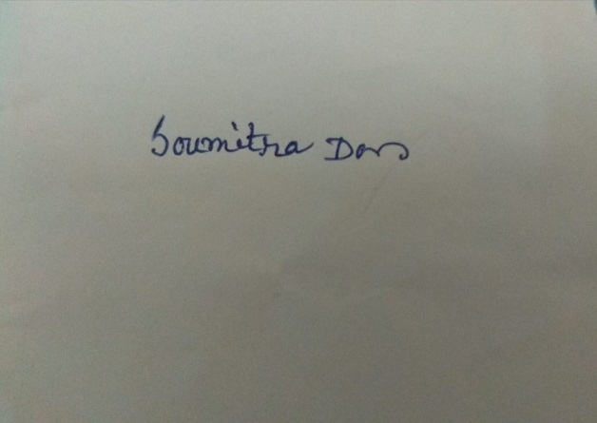
Signature

